Memo | 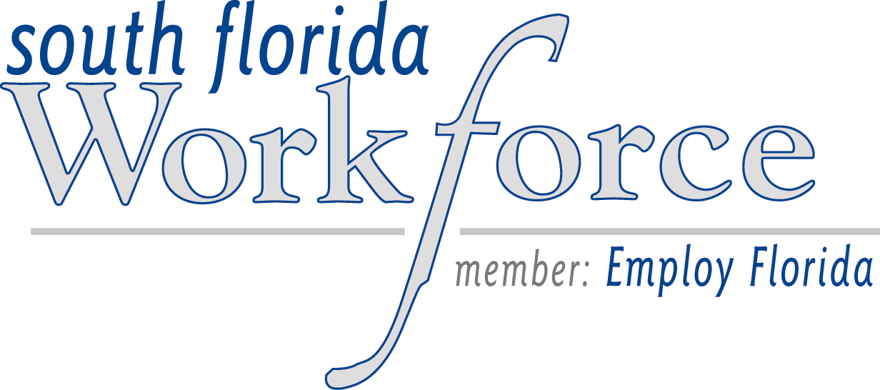

To: One Stop Career Center Managers
From: Denise Daley, Welfare Transition Program Administrator
Date: January 11, 2005
Re: Department of Children and Families Functional Workload
The purpose of this memo is to advise One Stop Operators of significant changes in the manner in which the DCF is conducting business. The workload is being "functionally" specialized as follows:

The Case Maintenance Unit (CMU), (DCF Hialeah South) is handling all data exchanges, i.e, sanction impositions, job placements alerts, exception & mass changes reports, Bill Tracking and other functions related to satisfying the needs of PROVIDERS in the community. This includes South Florida Workforce One Stop Career Centers, Child Support Enforcement, and Medical Providers etc. They do not physically have the customers’ case records, since updates are strictly on FLORIDA. The CMU is not meant to have any face-to-face contact with the customer, however the CMU may contact the client via phone or mail in order to obtain verification/documentation in order to process an alert or clarify information submitted by a provider. The CMU is specific to Miami-Dade & Monroe Counties.

The Customer Call Center (DCF Rhode Building) handles information & referrals, changes reported by the clients or their designated representatives, strictly by phone, fax or mail. This includes address changes, add/remove -a-person from assistance; the client reports loss/increase of income or employment. This was never designed with the intention of handling in-person contacts with either the client or the community. The Customer Call Center handles phone, fax & mail traffic for districts 8, 9, 10, 11which encompasses the entire SOUTHERN portion of the state from West Palm Beach to the KEYS including the west coast south of Tampa. The Customer Call Center also is working strictly FLORIDA and do not have the customers’ case files.

The Customer Service Centers (DCF service centers) are responsible for applications, redeterminations, hearings, and also troubleshoot issues discovered by both CCC & CMU in the course of processing change, alerts, etc. The service centers have the paper case files and continue to have face-to-face contact/ interviews with the customers.

DCF anticipates that in the near future, they will be coordinating with community partners/ providers to have the capability to complete applications off site via the Internet. So that, for example, if a customer in need shows up at a One Stop, he can apply for benefits via the WEB at the same time that he is looking for employment.

.

