Memo | 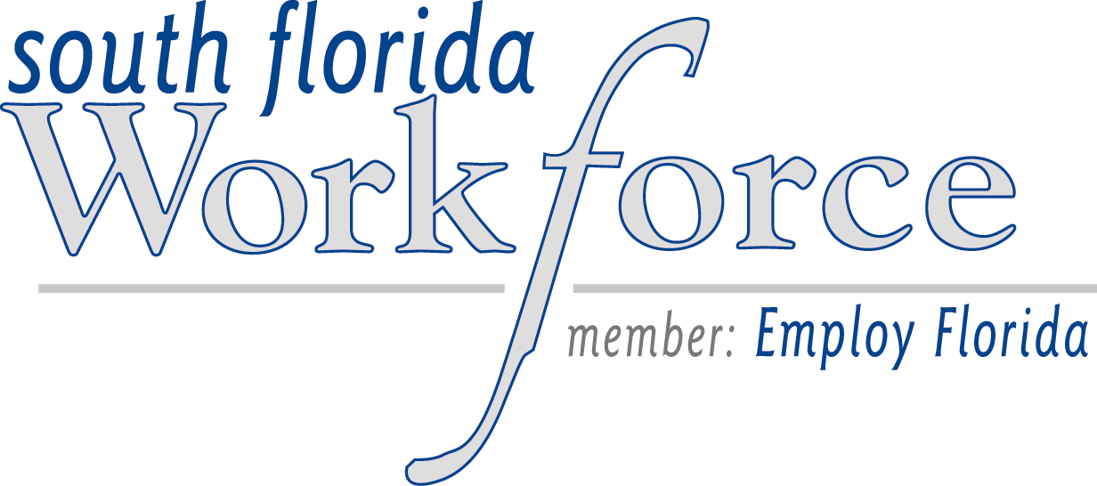

To: One –Stop Career Center Managers
From: Lawrence Suran, SFETC Program Director
CC: Edith Humes-Newbold, SFETC Executive Director
Date: March 1, 2004
Re: Welfare Transition Program – Childcare Referrals
The Miami-Dade Readiness Coalition, the administrative entity which contracts with Family Central and the Child Development Services (CDS) for Welfare Transition childcare services, has informed South Florida Workforce that effective today, all childcare referrals for Welfare Transition customers must be made to the Child Development Services agency, only. Please note that the Hialeah Gardens One Stop Career Center, only, will begin making referrals to CDS, on March 2nd. The Coalition no longer contracts with Family Central for childcare services and had anticipated a transition where by March 11th, Family Central would no longer be providing services. However since the transition plan has not been realized as anticipated, Career Advisors need to immediately begin making referrals only to CDS.
The attached represents the revised schedule/staffing arrangements for the One-Stop Career Centers which were staffed by Family Central. These scheduling arrangements were made in agreement with CDS and the One Stop Operator.
One Stop CDS Staff Person *Address Schedule
(if different from One Stop)
Carol City Shawanda Coffie n/a M-F 8am – 5pm
North Miami Beach Junelle Salvant n/a M & W 8am – 5pm
NMB Annex Martha Santiago n/a M-F 8am – 5pm
Hialeah Gardens Sandra Del Pino n/a M-F 8am-5pm
Hialeah Central (CDS Eligibility Office) 5400 NW 22 Ave M-F 8am – 5pm
Suite 204
(305) 633-6481

Hialeah Downtown (CDS Eligibility Office) 5400 NW 22 Ave M-F 8am – 5pm
Suite 204
(305) 633-6481

Miami Beach Vivian Marban n/a W 8am – 5pm

Northside Gayle Jones n/a M-F 8am – 5pm

